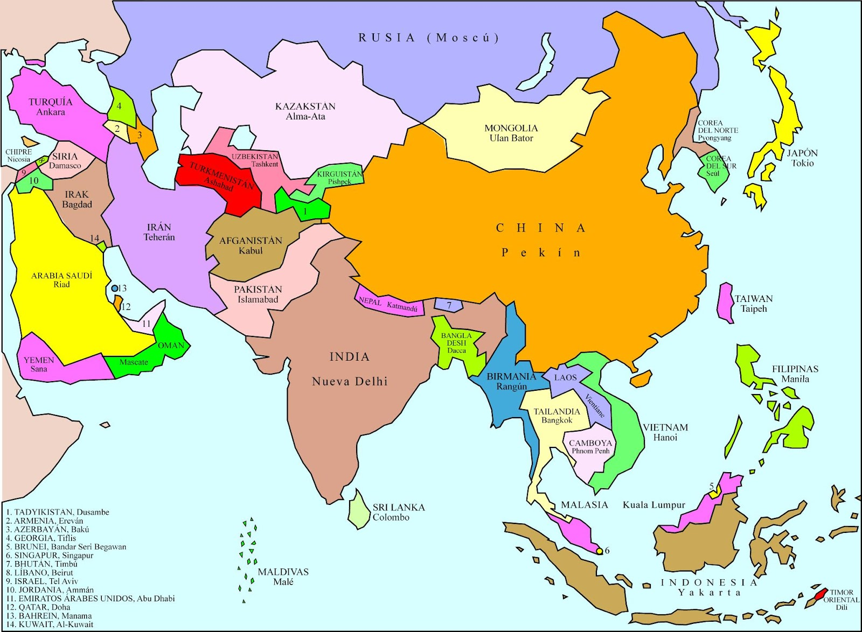

Città Capitale | Paese
Abu Dhabi (Abu Zabi, Abu Zaby (ae)) | Emirati Arabi
Amman | Giordania
Astana | Kazakhstan
Baghdad | Iraq
Beijing (Peking) | Cina
Beirut (Bayrut, Beiroût (lb) | Lebanon
Hanoi (Hà Nôi (vn) | Viet Nam
Jakarta | Indonesia
Jerusalemme | Israele
Kabul (Kabol) | Afghanistan
Kathmandu | Nepal
Kuala Lumpur | Malaysia
Kuwait (City) (Al Kuwayt) | Kuwait
Lhasa | Tibet
Manila | Philippine
New Delhi (Ni Dilli) | India
Phnom Penh (Phnum Pénh) | Cambogia
P'yongyang | Korea , Nord
Riyadh (Ar Riyad) | Arabia Saudita
Seul (Soul) | Korea , Sud
Taipei | Taiwan
Tehran | Iran
Tokio | Giappone
Ulaanbaatar (Ulan Bator) | Mongolia

